LinkedIn Data

# **Introduction**

The purpose of this report is to analyze and decode a decade's worth of social media data from one of Playhouse Communication's high-profile clients. The data, which spans across four major social media platforms - Facebook, Instagram, LinkedIn, and Twitter, provides a unique opportunity to gain deep insights into the client's digital engagement patterns.

Playhouse Communication, a leading digital marketing agency in Nigeria, has been managing the client's social media platforms for the past 10 years. This report aims to transform the raw data from these platforms into actionable insights that could redefine the future of digital marketing for the client.

The data has been provided in both .csv and .xls formats, allowing for comprehensive analysis using various data processing and analytics tools. The goal is not just to understand past trends but also to predict future ones, thereby providing the client with a strategic advantage in their digital marketing efforts.

This isn't just a hackathon; it's an opportunity to shape the future of digital engagement. By leveraging this exclusive social media data, we aim to strike gold with game-changing insights that could potentially revolutionise digital marketing strategies for Playhouse Communication and its clients.

# **Methodology**

The methodology for analysing the social media data involves several steps:

1. **Data Cleaning**: The first step in the process is data cleaning. This involves handling missing values, removing unnecessary columns, and converting data types where necessary. For instance, any columns with more than 50% missing values are dropped from the data.

2 **Exploratory Data Analysis (EDA):** This step involves understanding the distribution of data and relationships between different variables. For example, using time_series_analysis to plot various metrics over time.

3. **Topic Modeling using Latent Dirichlet Allocation (LDA)**: LDA is used to discover the main topics that occur in the collection of social media posts. This unsupervised machine learning technique assumes that each document (or post) is a mix of various topics, and each topic is a collection of words. By looking at which words often appear together, LDA can figure out the possible topics and how much each document belongs to each topic.

4. **Named Entity Recognition (NER) and Part-of-Speech Tagging (POS)**: These Natural Language Processing (NLP) techniques are used to extract more information from the text data. NER can tell us which specific entities (like people, places, or organisations) are being mentioned in the posts, while POS tagging helps us understand the context better by knowing the grammatical role of each word.

5. **Data Visualization**: The last step involves visualising the results of our analysis. This could be as simple as bar plots or pie charts showing the distribution of posts across different topics, or more complex visualisations like word clouds that highlight the most frequently mentioned entities in each topic.

The tools used for this analysis include Python for data cleaning and analysis, various libraries like pandas for data manipulation, matplotlib and plotly for data visualization, and sklearn and nltk for machine learning and NLP tasks.

# **Findings**

**Impressions:** This is the total number of times your content, whether a post or a story, was shown to users. If your Instagram impressions are higher than your reach, it’s a sign that your audience is viewing your content multiple times.

**Organic Impressions:** This metric represents the number of times your post appeared in people’s newsfeeds without any paid promotion. It gives you an indication of the number of people who may have seen the post, thus giving you an idea of your brand awareness growth, organic reach, and the number of impressions.

#### Data Preprocessing

The data preprocessing stage involved several crucial steps to ensure the data was in an appropriate format for analysis.

Conversion of Data Types

Initially, the 'Impressions', 'Organic Impressions', columns were categorical. To facilitate better analysis, these columns were converted to numerical data types. The conversion process involved removing commas from the values and converting the data type to integer. The code snippet for this process is as follows:

*```python*

*cleaned_impressions_reach[impression_cols] = cleaned_impressions_reach[impression_cols].apply(*

*lambda row:row.str.replace(',','').astype("int"), axis=1)*

*cleaned_impressions_reach[reach_cols] = cleaned_impressions_reach[reach_cols].apply(*

*lambda row:row.str.replace(',','').astype("int"), axis=1)*

*```*

#### 

#### Handling Missing Data

Upon checking for missing data, it was found that there were 1428 missing values in both the 'Impressions' and 'Organic Impressions' columns. Given the importance of these columns for analysing post performance, rows with missing data for these columns were dropped. The code snippet for this process is as follows:

*```python*

*cleaned_impressions_reach = cleaned_data*

*for col in cleaned_impressions_reach[impression_cols].columns:*

*cleaned_impressions_reach = cleaned_impressions_reach[cleaned_impressions_reach[col].notna()].reset_index(drop=True)*

*```*

These preprocessing steps were essential in ensuring that the subsequent analysis was based on complete and appropriately formatted data.

#### 

#### Feature Engineering

Feature engineering is a crucial step in any data analysis or machine learning project. It involves creating new features from existing ones to better capture the underlying patterns in the data. In this project, several new features were engineered from the date and time of each post.

Time-Based Features

The date and time when a post was made can have a significant impact on its performance. To capture this, the following features were created:

- ‘year’, ‘month_name’, ‘month’, ‘day_name’, ‘day’, ‘hour’, ‘minute’: These features represent the exact time when a post was made.

- ‘day_of_week’: This feature represents the day of the week (Monday, Tuesday, etc.) when a post was made.

- ‘time_period’: This feature categorizes the hour of the day into different time periods (morning, afternoon, evening, night).

- ‘quarter’: This feature represents the quarter of the year when a post was made.

- ‘season’: This feature represents the season (spring, summer, etc.) when a post was made.

- ‘day_period’: This feature categorizes the day of the week into weekdays or weekends.

Holiday Features

Holidays can also affect post performance as user behavior might change during these days. To capture this, a list of Nigerian holidays was used to create two new features:

- ‘holiday_names’: This feature indicates whether a post was made on a holiday, and if so, which holiday it was.

- ‘holiday_types’: This feature indicates the type of holiday (if any) on which a post was made.

These newly engineered features provide additional information that can help in understanding patterns in post performance. For instance, posts made during certain time periods or on certain holidays might receive more impressions or engagement. By including these features in our analysis, we can ask more detailed questions and gain deeper insights into your data.

#### Exploratory Data Analysis

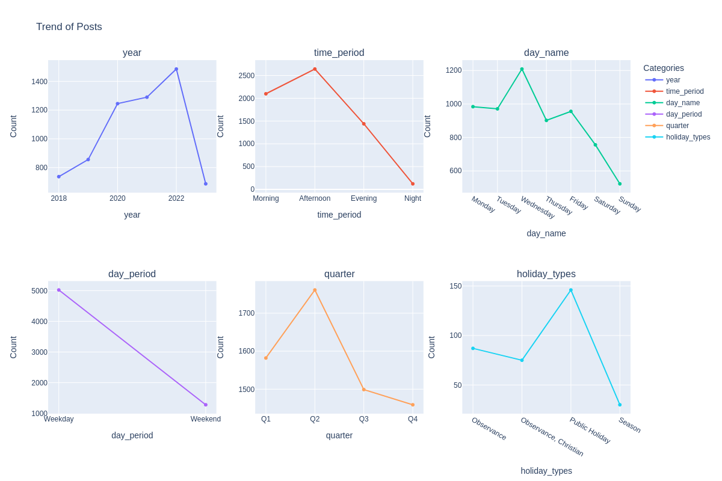

TREND OF POSTS

The graph above shows the count of posts made each year from 2016 to 2023. Here’s what we can infer from it:

* **Increase in Activity Over Time**: There is a general trend of increasing activity over the years, with the number of posts rising from 737 in 2018 to a peak of 1486 in 2022. This could indicate a growing use of the platform or an increase in content production strategies over time.
* **Peak in 2022**: The highest number of posts were made in 2022, which might suggest a particularly active year for content creation. This could be due to various factors such as increased marketing efforts, special events, or changes in content strategy.
* **Drop in 2023**: There’s a noticeable drop in the number of posts in 2023 compared to the previous year. However, it’s important to note that the data for 2023 might not be complete since we’re still within that year.
* **Time of Day**: Most posts are made in the afternoon (2642 posts), followed by morning (2098 posts), and evening (1439 posts). The least activity is at night (122 posts). This could indicate that the page is most active during daylight hours, possibly to match peak user activity times.
* **Day of the Week**: Wednesday sees the highest number of posts (1209 posts), while Sunday has the least (523 posts). This could suggest a strategy of posting more on weekdays when users might be more active.
* **Weekday vs Weekend**: There are significantly more posts on weekdays (5023 posts) compared to weekends (1279 posts), indicating a focus on reaching users during the workweek.
* **Quarterly Distribution**: The number of posts is fairly evenly distributed across quarters, with Q2 seeing slightly more activity (1761 posts). This could suggest a consistent content strategy throughout the year.

|  | **count** | **mean** | **std** | **min** | **25%** | **50%** | **75%** | **max** |
| --- | --- | --- | --- | --- | --- | --- | --- | --- |
| **Impressions** | 6332.0 | 1083.303696 | 1416.178616 | 1.0 | 476.0 | 775.0 | 1233.0 | 37889.0 |
| **Organic Impressions** | 6332.0 | 1083.303696 | 1416.178616 | 1.0 | 476.0 | 775.0 | 1233.0 | 37889.0 |

* **Count**: There are 6332 entries in all columns, indicating that there are no missing values in these columns.
* **Mean**: On average, a post gets around 1083 impressions, both organically and overall.
* **Standard Deviation (std)**: The standard deviation is 1416.17, which is quite high. This indicates that the number of impressions per post varies widely from the mean.
* **Minimum (min)**: The minimum number of impressions a post has received is 1.0. This could be due to posts that didn’t reach the audience or failed to engage them.
* **25th Percentile (25%)**: 25% of the posts received 476 impressions or less.
* **Median (50%)**: The median number of impressions per post is 775 Since the median is less than the mean, it indicates that the distribution of impressions is skewed to the right, with a few posts getting a very high number of impressions.
* **75th Percentile (75%)**: 75% of the posts received 1233 impressions or less.
* **Maximum (max)**: The maximum number of impressions a post has received is 37889. This indicates that some posts were highly successful in reaching a large audience.

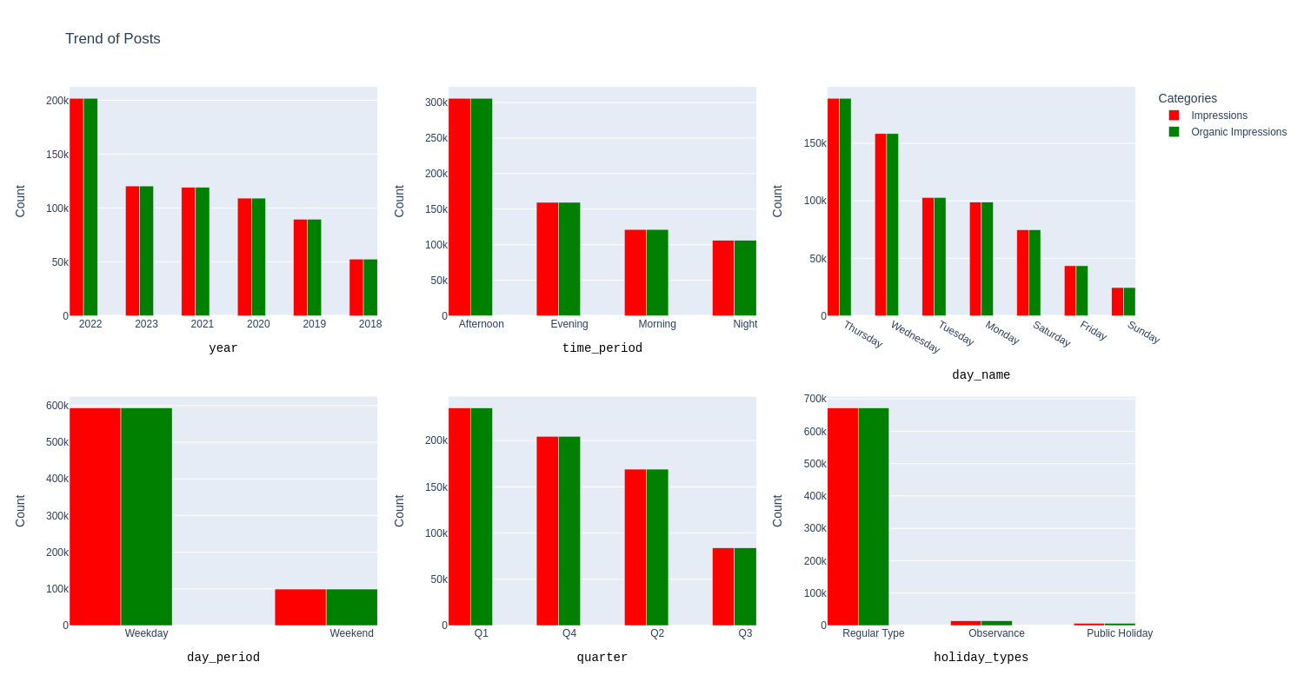

To effectively interpret the data provided, we might want to consider the following questions:

1. **How does the number of impressions and organic impressions vary by year?** The data shows a yearly breakdown of these metrics, which can help us understand trends over time.
2. **What are the peak times for impressions and organic impressions?** By looking at the breakdown by time period, we can identify when users are most active or engaged.
3. **How do impressions and organic impressions vary by day of the week?** This can reveal patterns in user behavior on different days.
4. **Is there a difference in engagement during weekdays versus weekends?** The ‘day_period’ data can help us understand if user engagement changes during these periods.
5. **How do impressions and organic impressions vary by quarter?** This can provide insights into seasonal trends in user engagement.
6. **Is there a difference in engagement on holidays versus regular days?** The ‘holiday_types’ data can reveal if user behavior changes during holidays.

The data shared provides insights into the distribution of the top 1% of posts based on impressions across different categories. Here’s what we can infer from it:

* **Yearly Distribution**: The year 2022 had the highest number of impressions, followed by 2023 and 2021. This could indicate that the content strategy in these years was particularly effective in reaching a large audience.
* **Time of Day**: Posts made in the afternoon have the highest impressions, followed by evening and morning. This suggests that these are the optimal times for posting to reach a larger audience.
* **Day of the Week**: Thursday has the highest number of impressions, followed by Wednesday and Tuesday. This indicates that weekends might be the best time to post for maximum reach
* **Quarterly Distribution**: The first quarter (Q1) has the highest number of impressions, followed by Q4 and Q2. This could be due to seasonal trends or specific marketing campaigns during these periods

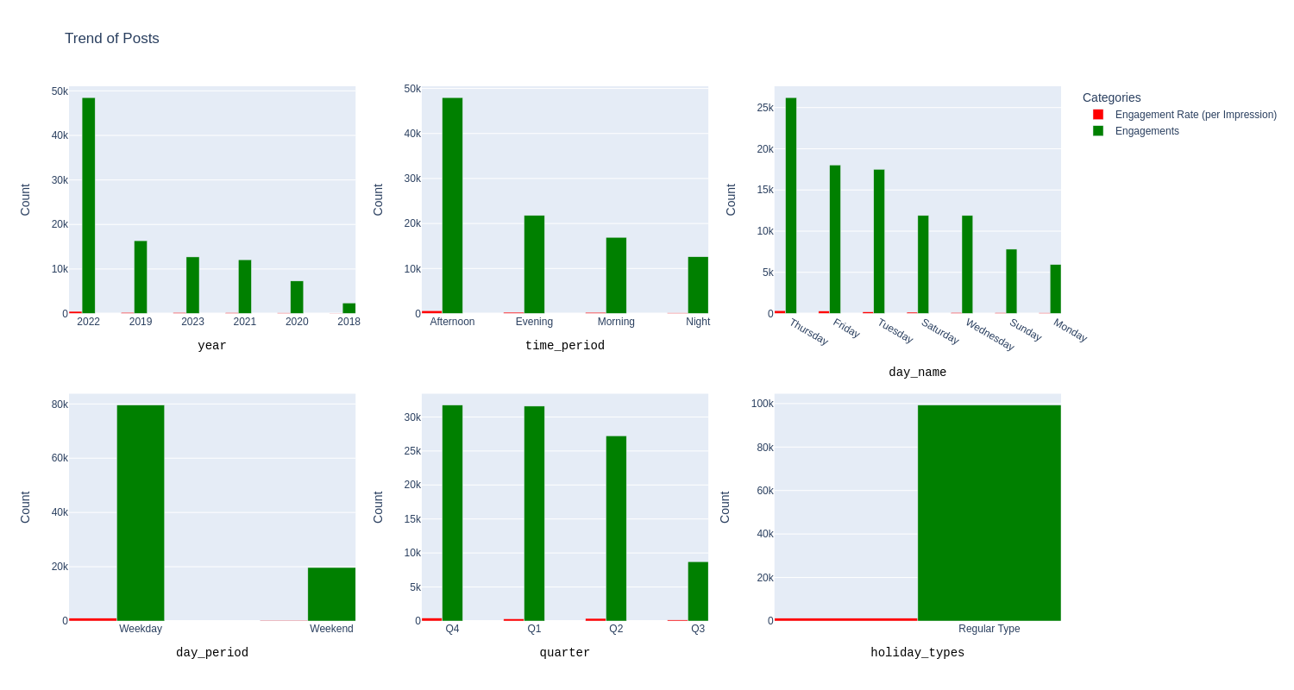

The data shared provides insights into the top 1% of posts based on engagements across different categories. Here’s what we can infer from it:

* **Yearly Distribution**: The year 2022 had the highest number of engagements, followed by 2019 and 2023. This suggests that the content strategy in these years was particularly effective in engaging the audience.
* **Time of Day**: Posts made in the Afternoon have the highest engagements, followed by evening and morning. This suggests that these are the optimal times for posting to engage a larger audience.
* **Day of the Week**: Thursday has the highest number of engagements, followed by Friday and Tuesday. This indicates that these days might be the best to post for maximum engagement.
* **Quarterly Distribution**: The fourth quarter (Q4) has the highest number of engagements, followed by Q1 and Q2. This could be due to seasonal trends or specific marketing campaigns during these periods.
* **Holiday Types**: Regular type posts have significantly higher engagements than posts made on holidays. This could indicate that regular posting is key to maintaining high engagement levels.

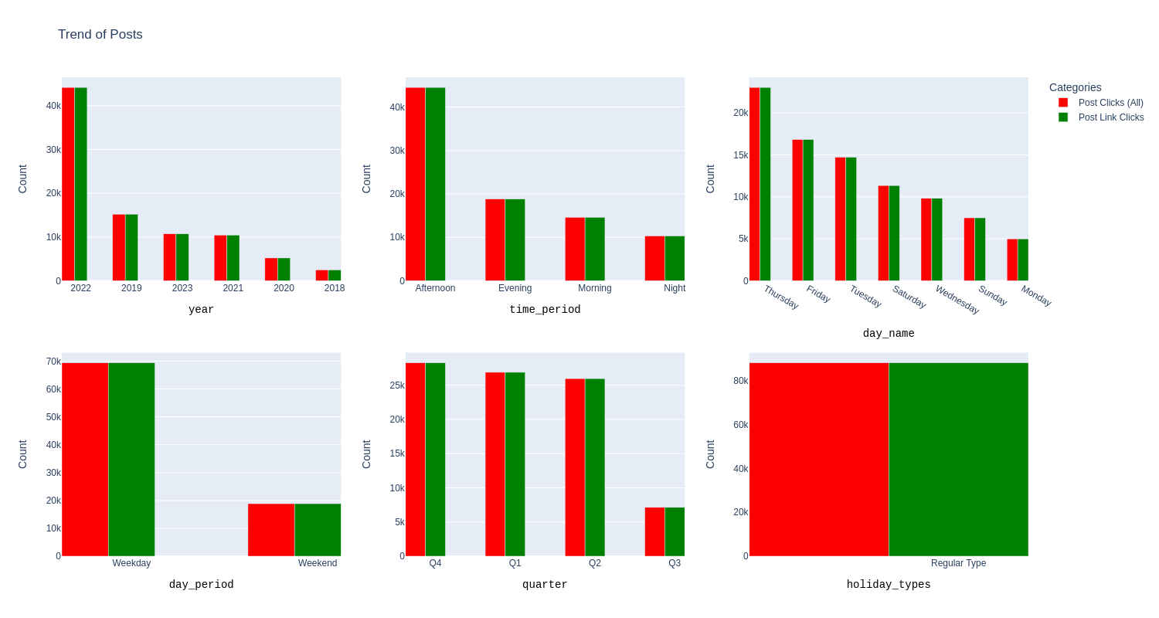

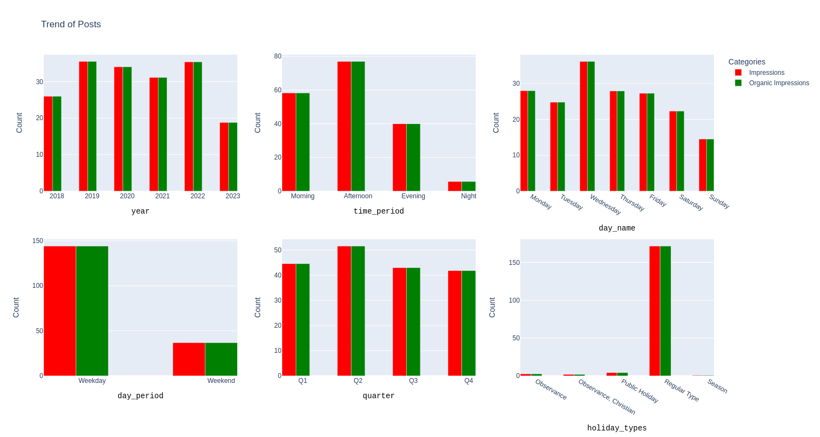

The data shared provides insights into the distribution of Impressions and Organic Impressions across different categories. Here’s what we can infer from it:

* **Yearly Distribution**: The year 2022 had the highest number of impressions, followed by 2019 and 2020. This suggests that the content strategy in these years was particularly effective in reaching a large audience.
* **Time of Day**: Posts made in the afternoon have the highest impressions, followed by morning and evening. This suggests that these are the optimal times for posting to reach a larger audience.
* **Day of the Week**: Wednesday has the highest number of impressions, followed by Friday and Monday. This indicates that these days might be the best to post for maximum reach.
* **Weekday vs Weekend**: Impressions are significantly higher on weekdays compared to weekends. This suggests that posting on weekdays is more effective for reaching a large audience.
* **Quarterly Distribution**: The second quarter (Q2) has the highest number of impressions, followed by Q1 and Q4. This could be due to seasonal trends or specific marketing campaigns during these periods.
* **Holiday Types**: Regular type posts have significantly higher impressions than posts made on holidays. This could indicate that regular posting is key to maintaining high reach levels.

Comparing the insights from the overall impressions and the top 1% of impressions, we can observe several commonalities, differences, and contradictions:

**Commonalities**:

* Both datasets suggest that the afternoon is an optimal time for posting to reach a larger audience.
* Both datasets indicate that weekdays are generally more effective for reaching a large audience compared to weekends.

**Differences**:

* In terms of yearly distribution, while 2022 had the highest number of impressions in both datasets, the following years differed. In the overall impressions dataset, 2019 and 2020 followed 2022, whereas in the top 1% dataset, 2023 and 2021 followed.
* In terms of the day of the week, Wednesday had the highest number of impressions in the overall dataset, whereas Thursday had the highest in the top 1% dataset.

**Contradictions**:

* In terms of quarterly distribution, Q2 had the highest number of impressions in the overall dataset, whereas Q1 had the highest in the top 1% dataset.

These observations can impact our understanding of content performance and underlying assumptions in several ways:

* The commonalities reinforce certain assumptions, such as posts made in the afternoon on weekdays tend to have higher impressions.
* The differences suggest that while certain patterns hold true for all posts (like higher impressions during weekdays), other patterns may only emerge when looking at the most successful posts (like higher impressions in Q1).
* The contradictions challenge some of our assumptions and suggest that factors contributing to high impressions may not be straightforward and could vary depending on whether we’re looking at all posts or just the top-performing ones. For instance, while Q2 might be a good time for posting in general, for posts that perform exceptionally well (top 1%), Q1 might be a better time.

These insights highlight the importance of segmenting data and considering different perspectives when analyzing content performance. They also underscore that while certain strategies might work well on average, different strategies might be needed to achieve exceptional performance.

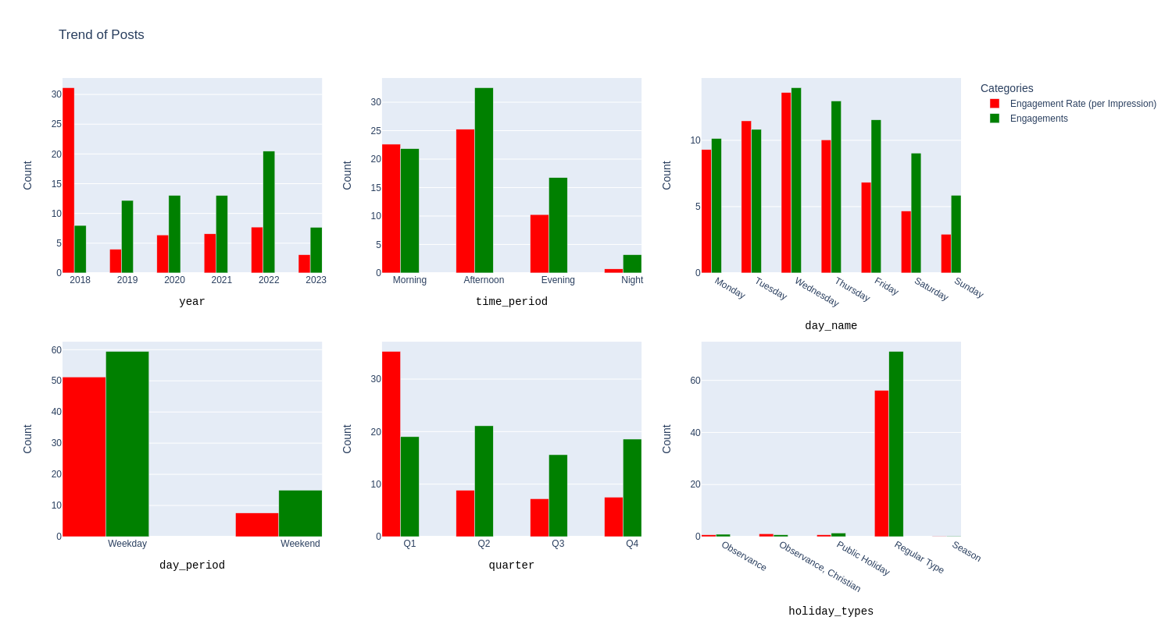

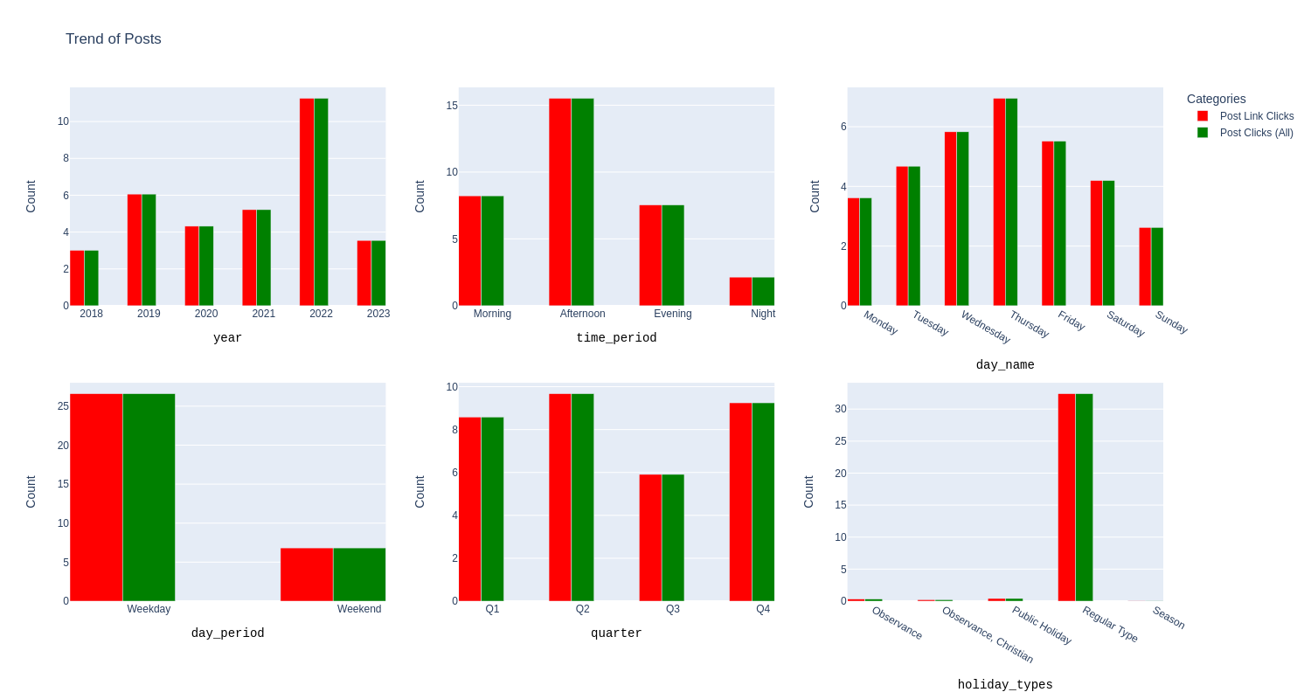

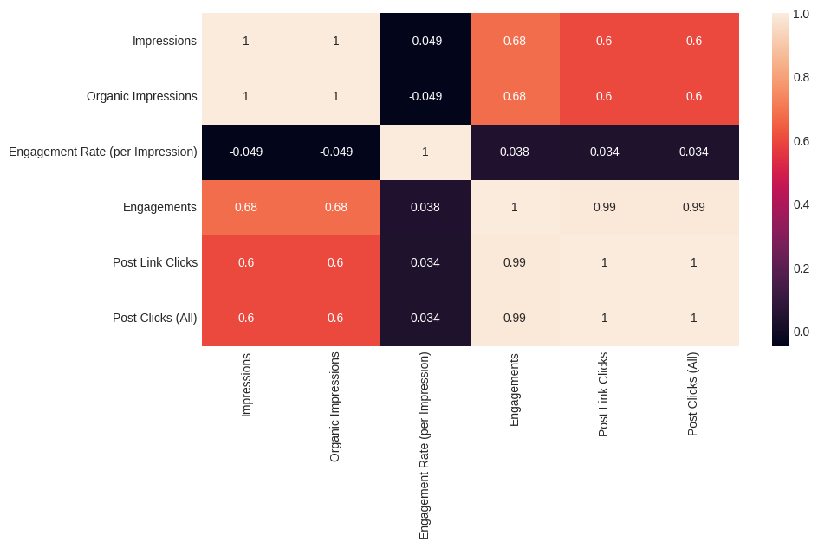

The data shared shows the correlation between different metrics. Here are some key findings:

1. **Impressions and Organic Impressions**: These two metrics have a perfect correlation of 1. This means that every time there’s an increase in impressions, there’s an equivalent increase in organic impressions. This could indicate that the majority of impressions are organic, not resulting from paid promotions.
2. **Impressions and Engagements**: There’s a strong positive correlation of 0.679538 between these two metrics. This suggests that as the number of times content is viewed increases (impressions), the number of engagements (likes, comments, shares) also increases.
3. **Engagements and Post Link Clicks/Post Clicks (All)**: These metrics have a very high positive correlation of approximately 0.988596. This indicates that posts with more engagements tend to have more clicks.
4. **Engagement Rate (per Impression) and Other Metrics**: The engagement rate has a very low correlation with other metrics, suggesting that it doesn’t significantly influence impressions, engagements, or clicks.

**How does post performance vary by time of day, day of the week, or season?** This can help identify the best times to post for maximum engagement.

We try out Time Series Analysis to uncover some Patterns

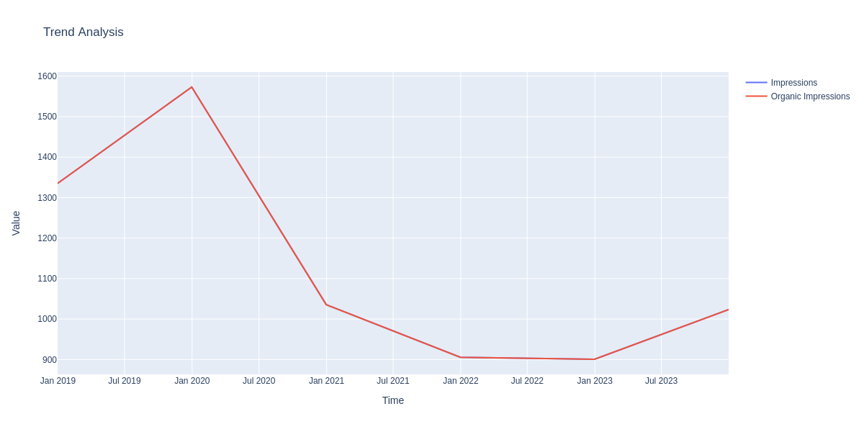

Yearly Trends

There has been a steady increase in impressions from 2019 to 2020, indicating that the content strategy employed during this period was effective. However, there was a noticeable drop in impressions from 2020 to 2023.

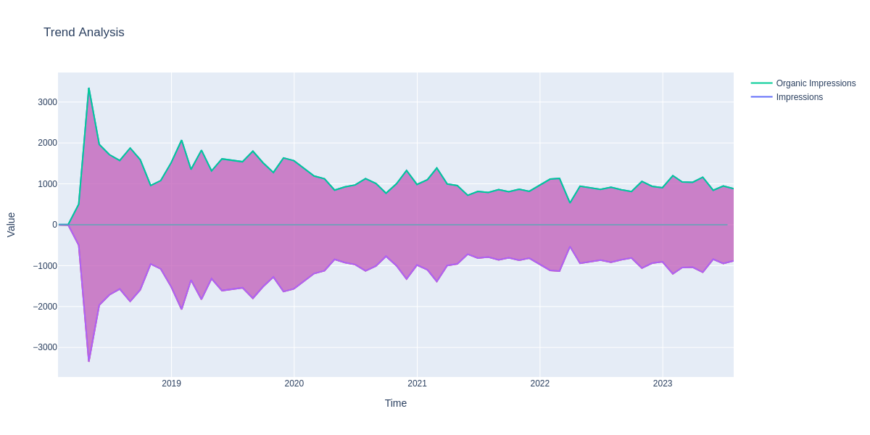

Monthly Trends

A month-by-month analysis shows a gradual decrease in impressions over the years. Notably, there were spikes in impressions in April 2018, Jan 2019, and Nov 2019, However, after Nov 2019, there was a consistent decline in impressions, reaching a low of 948 in June 2023.

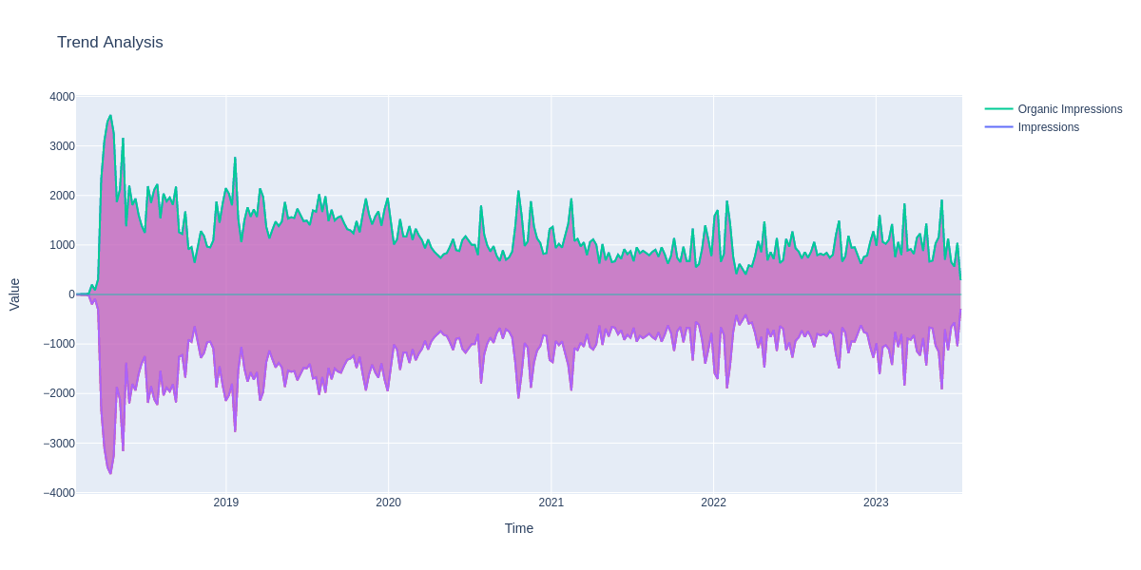

Weekly Trends

The weekly analysis also shows a slow but steady decrease in impressions over time. There were significant spikes in impressions during certain weeks - April 2018, Jan 2019, October 2020. After October 2020, the impressions started to decline, with the highest value being 1918 impressions in May 2023 and ending with just 564 Impressions in June 2023.

These findings are significant as they highlight the importance of both the quantity and timing of posts in driving user engagement. They suggest that to maximize impressions, it’s crucial to maintain a consistent posting schedule and to consider the timing of posts carefully.

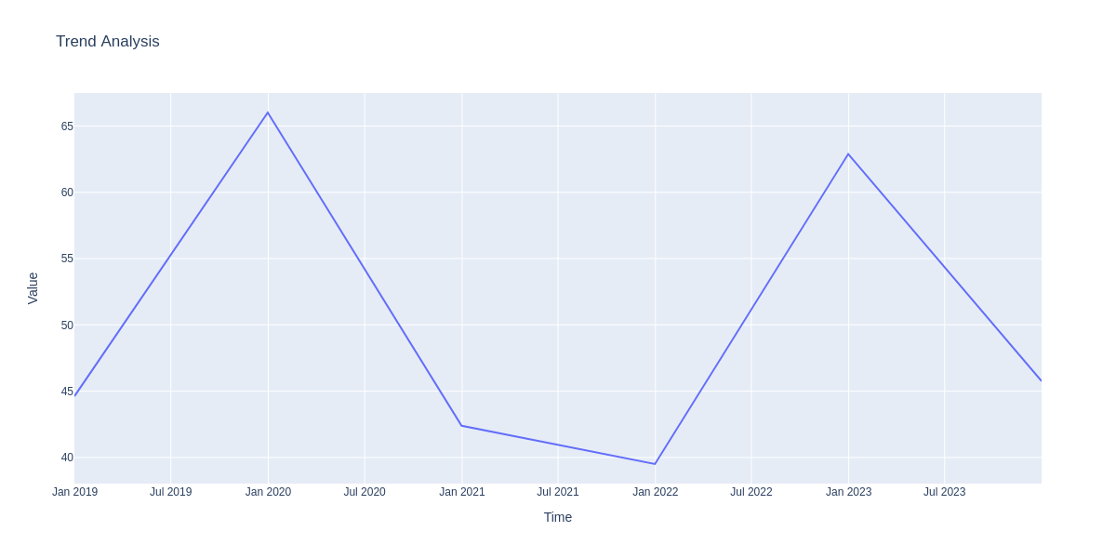

Analyzing our Engagements over the years and we see 2 Peaks, from 2019 to 2020, suddenly dropping in 2020/2021 and then rising to a peak in 2023, and dropping from the beginning of the year.

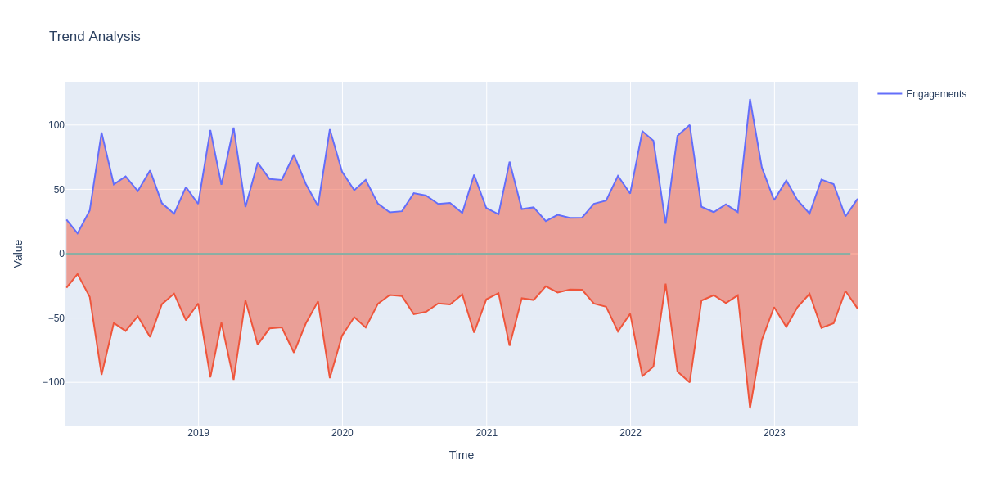

Analyzing our Engagements over the Months it shows the sharp increases in Engagements from the year 2018 till the month Nov 2019, after which we see a decline till the month Jan 2022 after that we see a sudden increase in Engagements in Jan 2022-Oct 2022, but then we see it declines

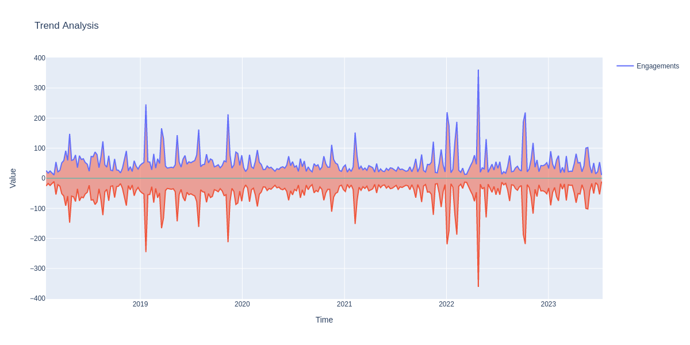

We observe the same trends observed in Engagement Columns in the Click Columns, this is proof of the strong positive correlation

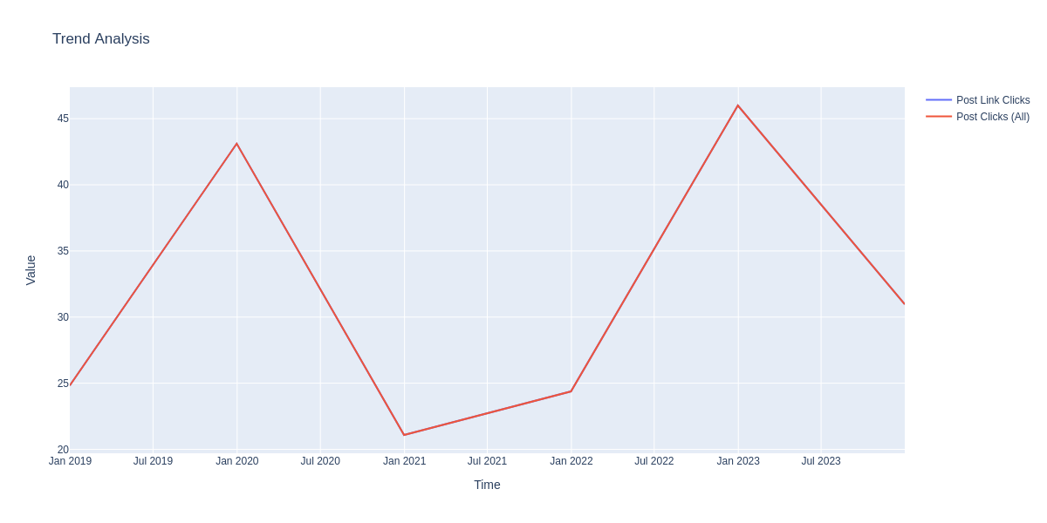

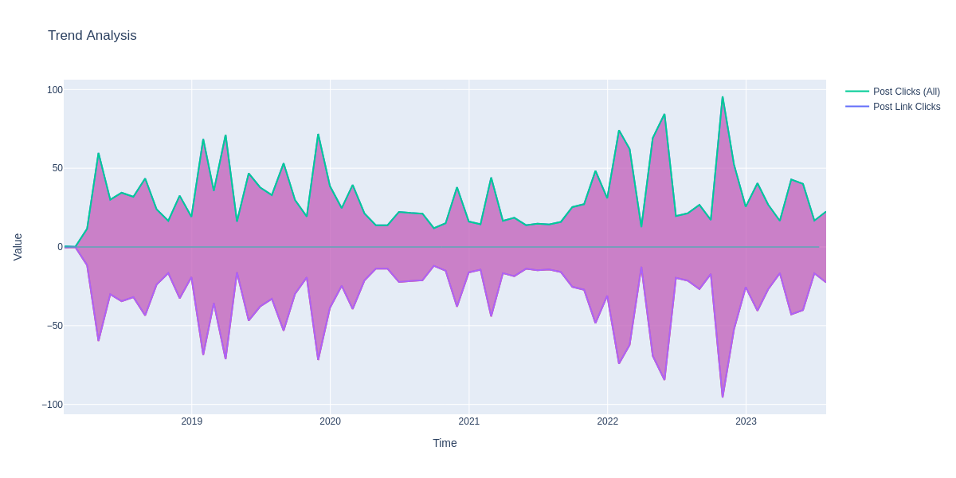

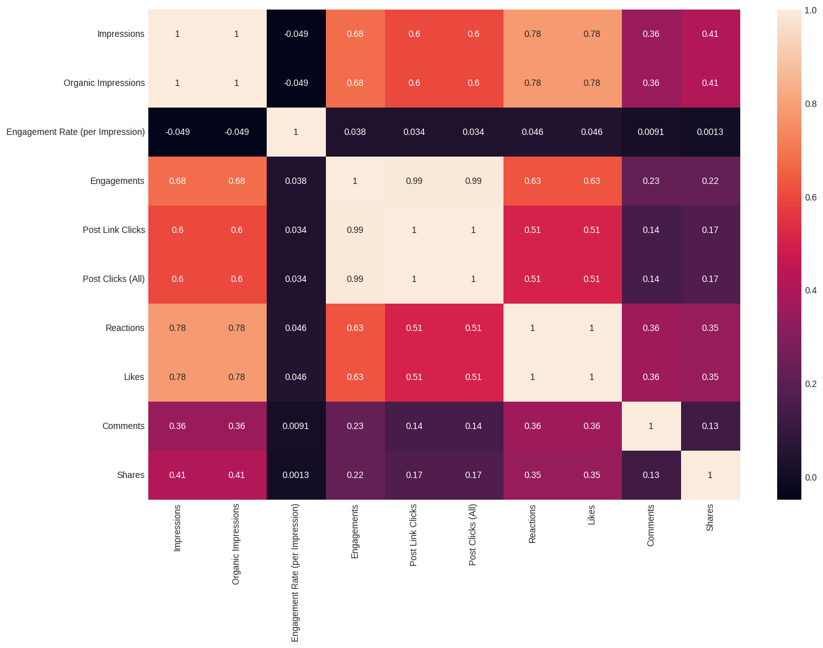

We see the correlation of the Reaction, Likes, Comments and Shares Columns with the rest of our dataset, we see a positive correlation of 0.78 between Reactions, Likes and Impressions/Organic Impressions, we also see a strong positive correlation between Engagements, Post Link Clicks, Post Link Clicks, across Reactions an Likes too

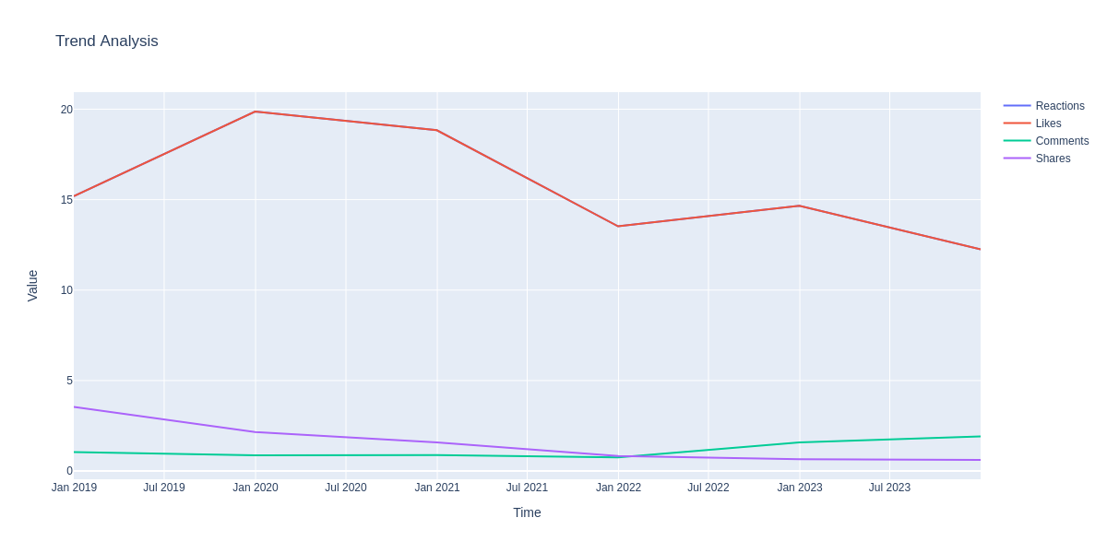

Analyzing the trend of LinkedIn Reactions, Likes, Comments and Shares on our Posts, we see it increases from 2019-2020, but reduces from 2020-2022

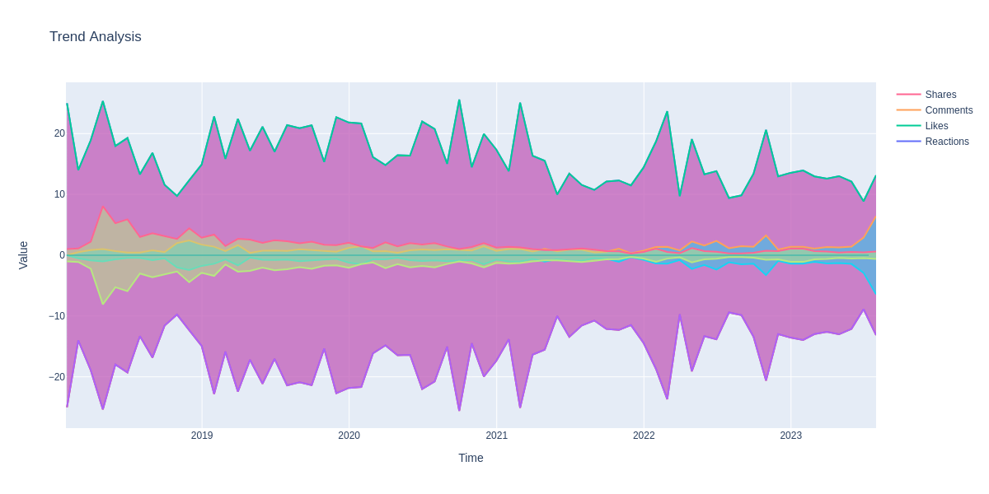

Across the Months we see an increase from 2019 - July 2022, and then drops till 2023

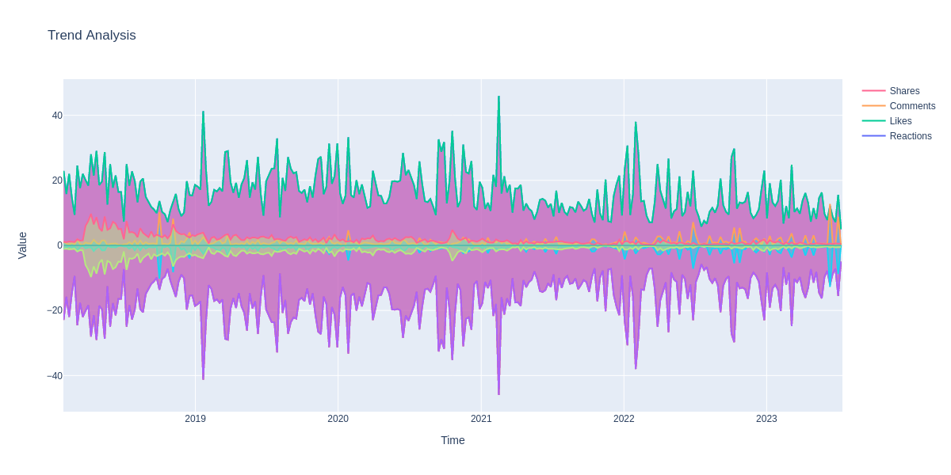

The methodology for analyzing the social media posts involves several steps:

1. **Data Cleaning**: The first step in the process is data cleaning. This involves removing URLs, converting text to lowercase, removing punctuation, and removing stop words. Stop words are common words that do not contain important meaning and are usually removed from texts. An additional list of stop words was also used to remove more common words.
2. **Text Preprocessing**: The cleaned texts are then preprocessed using several techniques:
   * Removing text in square brackets.
   * Removing links.
   * Removing punctuation.
   * Removing words containing numbers.
   * Removing emojis.
3. **Applying the Cleaning Functions**: The cleaning functions are then applied to the ‘Post’ column of the data. The cleaned posts are stored in a new dataframe.

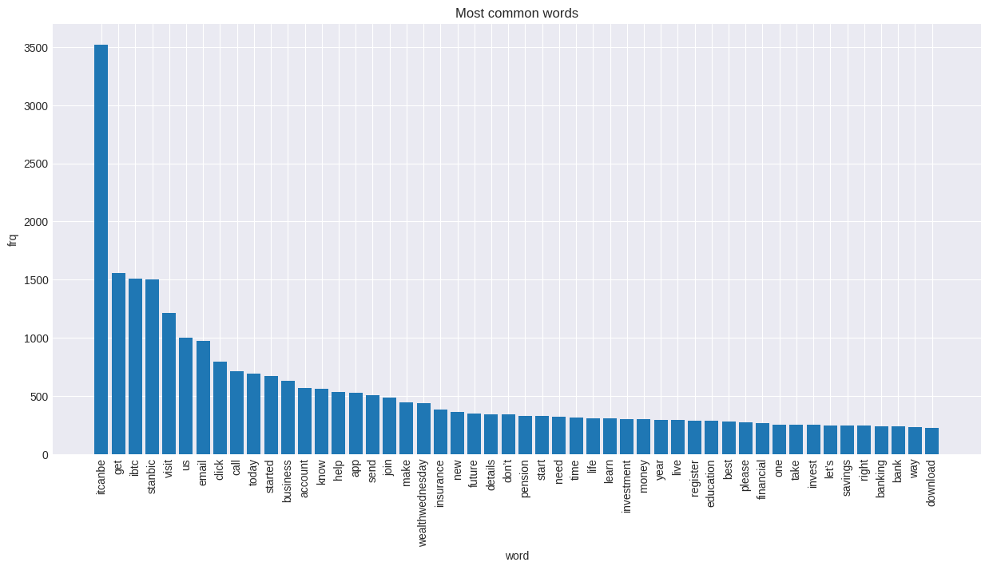

We can see the top most common words in our posts

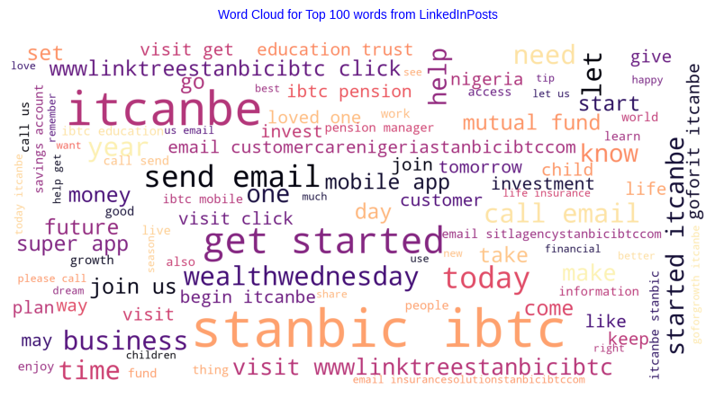

Here’s a Sentiment Analysis of our Posts

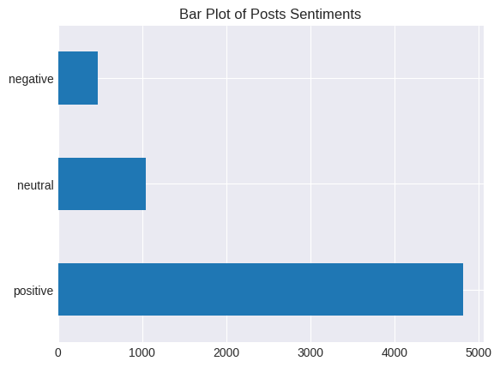

Using LDA to get the main topics in our dataset

Topic 0: join | itcanbe | register | live | happy | day | tomorrow | today | session | click | social | bluetalks | leave | know | walk

Topic 1: itcanbe | ibtc | stanbic | dreams | apply | highlights | conditions | cash | sector | pmi | infrastructure | visit | come | miss | face

Topic 2: itcanbe | visit | insurance | stanbic | click | ibtc | pension | life | today | help | let | started | wealthwednesday | business | email

Topic 3: movingforward | itcanbe | stay | know | bestinsurancedeals | health | online | staysafe | sdg | wealthwednesday | sustainable | safe | goal | development | care

Topic 4: itcanbe | stanbic | ibtc | app | account | email | details | visit | send | download | open | mobile | super | today | started

Topic 5: stanbic | ibtc | itcanbe | business | nigeria | school | growth | africa | bank | trade | watch | goforgrowth | head | capital | banking

Topic 6: itcanbe | email | started | help | let | visit | future | investment | education | send | invest | funds | set | start | know

Topic 7: itcanbe | people | savings | season | new | days | questions | live | years | promo | win | account | deposit | loved | easewallet

Based on the topics you've provided, here are 8 unique categories that could be created:

1. **Community Engagement & Events**: This category could include posts about joining events, registering for sessions, and social interactions (Topic 0).
2. **Dream Realization & Financial Services**: This category could cover posts related to realizing dreams, applying for financial services, and sector highlights (Topic 1).
3. **Insurance & Pension Services**: This category could include posts about insurance, pension services, and how to get started with them (Topic 2).
4. **Health & Sustainable Development**: This category could cover posts about health, online safety, and sustainable development goals (Topic 3).
5. **Digital Banking & Account Management**: This category could include posts about digital banking services, account management, and mobile banking apps (Topic 4).
6. **Business Growth & Banking Services**: This category could cover posts about business growth in Nigeria and Africa, banking services, and trade (Topic 5).
7. **Investment & Future Planning**: This category could include posts offering advice on investment, future planning, and education (Topic 6).
8. **Savings & Promotions**: This category could cover posts about savings, seasonal promotions, and winning opportunities (Topic 7).

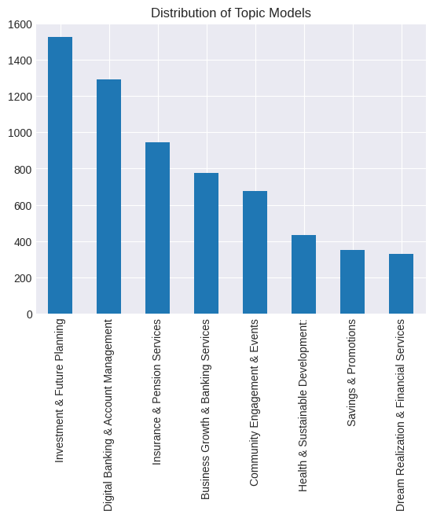

Posts about Investments & Future Planning have the highest count, after which comes Digital Banking and Account Management, lastly Dream Realization and Financial Services and Savings & Promotions are the lowest.

Parts of Speech (POS) Tagging and Named Entity Recognition (NER) can be quite useful in analyzing Instagram metrics and increasing the overall outreach of a post. Here’s how:

Content Analysis: POS tagging can help analyze the content of Instagram posts or comments. For example, the use of more verbs might indicate a call to action, while the use of adjectives might suggest descriptive content.

Sentiment Analysis: POS tagging can be used in sentiment analysis, which can provide insights into the audience’s perceptions and attitudes towards certain posts. This can help in tailoring content to evoke desired emotional responses1.

Trend Identification: NER can identify named entities such as people, organizations, or locations in the text. This can help identify trends or popular topics among users, which can be leveraged to create more engaging content1.

Personalization: NER can help in personalizing content. For example, if a lot of users are talking about a specific event or person, that information can be used to create targeted posts.

Improving Searchability: Using NER and POS tagging, posts can be annotated with metadata that improves their searchability. This can increase the visibility of posts and thereby increase impressions.

Competitor Analysis: These techniques can also be used to analyze the content strategies of competitors. This information can provide valuable insights and help in creating more effective content strategies.

|  | **VERB_count** | **ADV_count** | **ADJ_count** | **NUM_count** | **NOUN_count** | **SPACE_count** | **PROPN_count** | **pos_count** |
| --- | --- | --- | --- | --- | --- | --- | --- | --- |
| **topic_label** |  |  |  |  |  |  |  |  |
| **Business Growth & Banking Services** | 3.623226 | 0.353548 | 2.295484 | 0.095484 | 8.033548 | 0.717419 | 5.642581 | 21.637419 |
| **Insurance & Pension Services** | 4.348837 | 0.400634 | 1.996829 | 0.056025 | 7.248414 | 0.485201 | 2.115222 | 18.455603 |
| **Savings & Promotions** | 3.352273 | 0.397727 | 1.980114 | 0.241477 | 6.207386 | 1.886364 | 2.343750 | 17.738636 |
| **Digital Banking & Account Management** | 3.696594 | 0.395511 | 1.921053 | 0.099071 | 6.975232 | 0.790248 | 2.291796 | 17.622291 |
| **Health & Sustainable Development:** | 3.625287 | 0.514943 | 2.342529 | 0.087356 | 6.873563 | 0.666667 | 2.367816 | 17.604598 |
| **Community Engagement & Events** | 3.762537 | 0.410029 | 1.520649 | 0.067847 | 5.927729 | 0.930678 | 2.510324 | 16.505900 |
| **Investment & Future Planning** | 3.969160 | 0.412730 | 1.664042 | 0.064304 | 5.868766 | 0.488189 | 1.738189 | 15.950787 |
| **Dream Realization & Financial Services** | 2.624242 | 0.266667 | 1.733333 | 0.081818 | 4.839394 | 0.748485 | 2.969697 | 14.030303 |

The data shows the average count of different parts of speech (POS) for each topic label, sorted by the total POS count. Here are some key findings:

1. **Business Growth & Banking Services**: This topic has the highest average total POS count, indicating that it might be the most discussed or complex topic. The high counts of nouns and proper nouns suggest that specific entities and concepts are frequently mentioned.
2. **Insurance & Pension Services**: This topic has the second-highest average total POS count. The high verb count could indicate action-oriented discussions, possibly about policies or claims.
3. **Savings & Promotions**: This topic has a high count of spaces, which could suggest longer sentences or more complex discussions.
4. **Digital Banking & Account Management**: This topic also has a high noun count, suggesting discussions around specific features or issues.
5. **Health & Sustainable Development**: This topic has a relatively high adjective count, which could indicate descriptive discussions about health and sustainability initiatives.
6. **Community Engagement & Events**: This topic has a high count of verbs and proper nouns, suggesting action-oriented discussions about specific events or initiatives.
7. **Investment & Future Planning**: This topic has a relatively high verb count, indicating action-oriented discussions, possibly about investment strategies or future plans.
8. **Dream Realization & Financial Services**: This topic has the lowest average total POS count, suggesting it might be less discussed or simpler in nature.

|  | **CARDINAL_count** | **DATE_count** | **GPE_count** | **LOC_count** | **MONEY_count** | **ORDINAL_count** | **ORG_count** | **PERSON_count** | **TIME_count** | **ner_count** |
| --- | --- | --- | --- | --- | --- | --- | --- | --- | --- | --- |
| **topic_label** |  |  |  |  |  |  |  |  |  |  |
| **Business Growth & Banking Services** | 0.074839 | 0.327742 | 0.397419 | 0.040000 | 0.003871 | 0.025806 | 0.793548 | 0.483871 | 0.023226 | 2.323871 |
| **Savings & Promotions** | 0.099432 | 0.622159 | 0.196023 | 0.002841 | 0.025568 | 0.022727 | 0.457386 | 0.184659 | 0.017045 | 1.670455 |
| **Dream Realization & Financial Services** | 0.057576 | 0.412121 | 0.090909 | 0.000000 | 0.006061 | 0.009091 | 0.481818 | 0.375758 | 0.012121 | 1.512121 |
| **Community Engagement & Events** | 0.032448 | 0.480826 | 0.153392 | 0.004425 | 0.001475 | 0.011799 | 0.535398 | 0.209440 | 0.028024 | 1.510324 |
| **Digital Banking & Account Management** | 0.077399 | 0.245356 | 0.168731 | 0.003870 | 0.023220 | 0.020124 | 0.511610 | 0.219814 | 0.010062 | 1.320433 |
| **Health & Sustainable Development:** | 0.066667 | 0.418391 | 0.089655 | 0.002299 | 0.000000 | 0.020690 | 0.512644 | 0.142529 | 0.011494 | 1.280460 |
| **Insurance & Pension Services** | 0.044397 | 0.313953 | 0.188161 | 0.000000 | 0.001057 | 0.012685 | 0.483087 | 0.168076 | 0.013742 | 1.255814 |
| **Investment & Future Planning** | 0.049213 | 0.303150 | 0.188976 | 0.001312 | 0.000656 | 0.016404 | 0.469160 | 0.129265 | 0.007874 | 1.182415 |

The data shared shows the average count of different named entity recognition (NER) categories for each topic label, sorted by the total NER count. Here are some key findings:

1. **Business Growth & Banking Services**: This topic has the highest average total NER count, indicating that it might have the most diverse or complex discussions involving various entities. The high counts of GPE (Geo-Political Entities) and ORG (Organizations) suggest that specific locations and organizations are frequently mentioned.
2. **Savings & Promotions**: This topic has a high DATE count, which could suggest discussions around time-bound promotions or savings plans.
3. **Dream Realization & Financial Services**: This topic has a relatively high PERSON count, which could indicate discussions involving specific individuals or roles.
4. **Community Engagement & Events**: This topic has a high ORG count, suggesting discussions about specific organizations or groups.
5. **Digital Banking & Account Management**: This topic also has a high ORG count, suggesting discussions around specific banks or financial institutions.
6. **Health & Sustainable Development**: This topic has a relatively high DATE count, which could indicate discussions about timelines or deadlines for sustainable development goals.
7. **Insurance & Pension Services**: This topic has a relatively high GPE count, indicating discussions involving specific locations, perhaps related to regional insurance policies or pension plans.
8. **Investment & Future Planning**: This topic has the lowest average total NER count, suggesting it might be less diverse or simpler in nature.

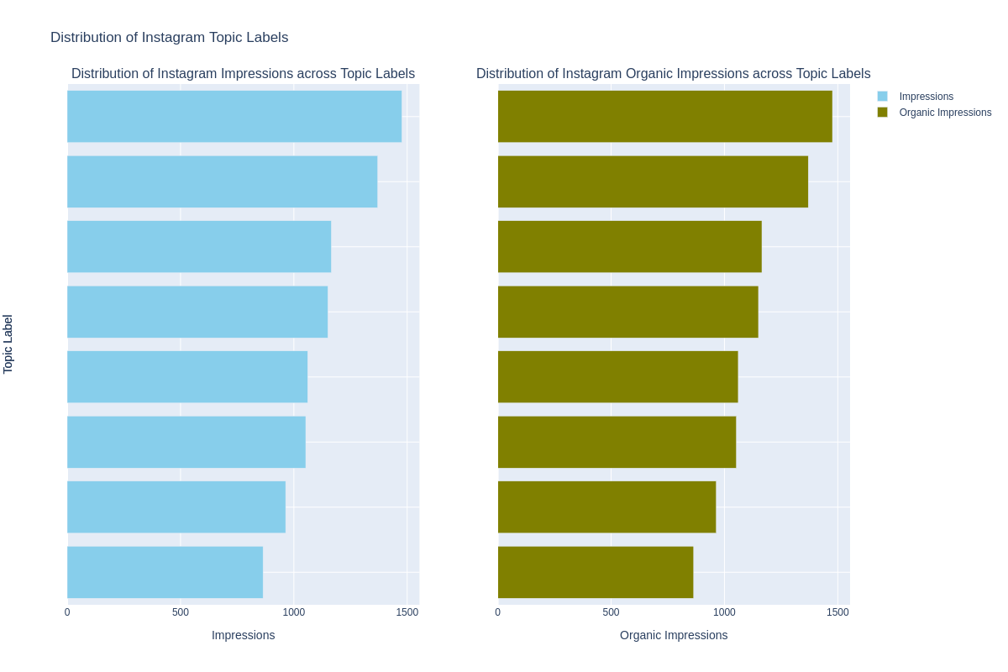

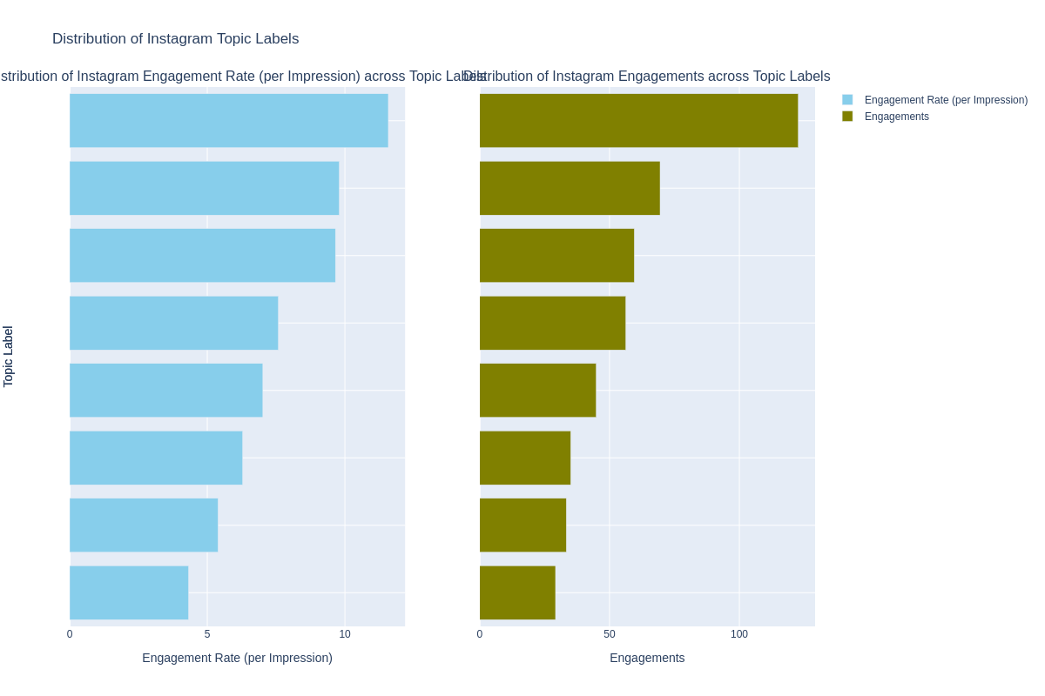

Based on the data shared, here are the topics that generate the most impressions and Engagements:

1. **Business Growth & Banking Services**: This topic generates the most impressions and engagements, indicating that it might be the most popular or interesting to your audience.
2. **Community Engagement & Events**: This topic has the second-highest average impressions but lower engagements, suggesting that while it reaches a wide audience, it might not be as engaging.
3. **Digital Banking & Account Management**: This topic has the lowest engagement rate, indicating that while it reaches a certain audience, it might not be as engaging.
4. **Dream Realization & Financial Services**: This topic has a relatively high number of impressions but a lower engagement rate, suggesting that while it reaches a wide audience, it might not be as engaging.
5. **Health & Sustainable Development**: This topic has a high engagement rate but lower impressions, suggesting that while it might not reach a wide audience, those who do see it find it engaging.
6. **Insurance & Pension Services**: This topic has relatively low impressions and engagements, suggesting that it might not be as popular or engaging.
7. **Investment & Future Planning**: This topic has relatively low impressions but a higher engagement rate, suggesting that while it might not reach a wide audience, those who do see it find it engaging.
8. **Savings & Promotions**: This topic has relatively high impressions and engagements, indicating that it might be popular and engaging to your audience.

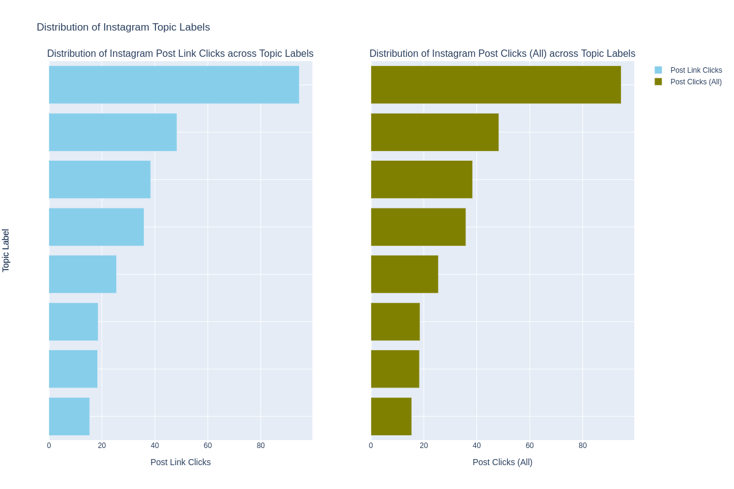

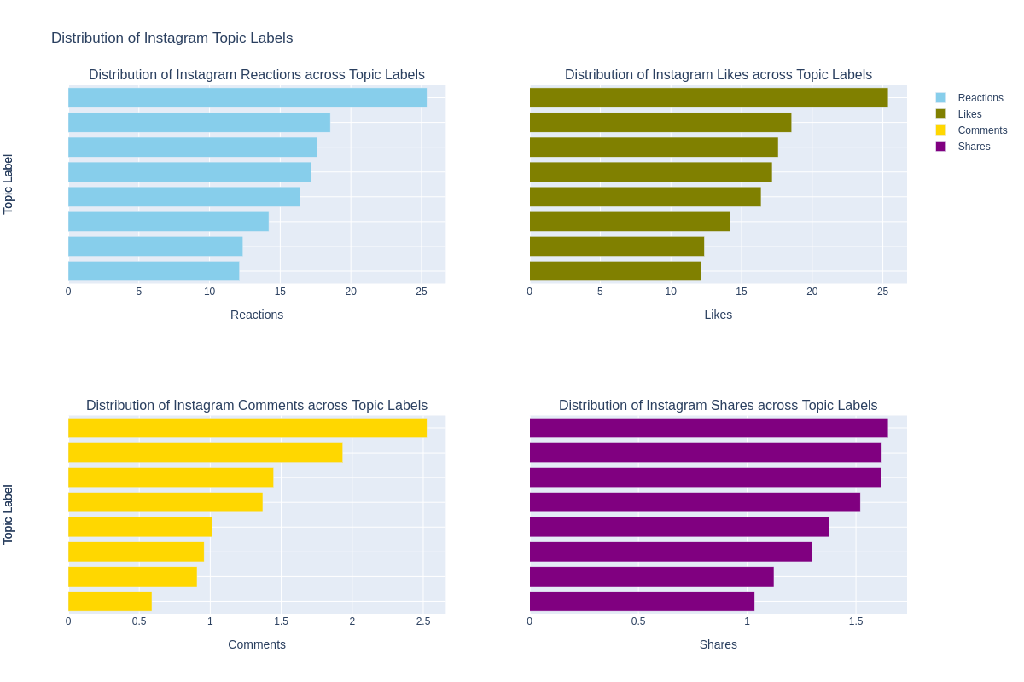

Based on the data shared, here are the topics that generate the most Reactions, Likes, Shares and Comments:

1. **Business Growth & Banking Services**: This topic generates the most post clicks, reactions, likes, comments, and shares, indicating that it might be the most popular or engaging to your audience.
2. **Community Engagement & Events**: This topic has the second-highest average post clicks but lower reactions, likes, comments, and shares, suggesting that while it reaches a wide audience, it might not be as engaging.
3. **Digital Banking & Account Management**: This topic has the lowest post clicks and reactions, indicating that while it reaches a certain audience, it might not be as engaging.
4. **Dream Realization & Financial Services**: This topic has a relatively high number of post clicks but a lower engagement rate (reactions, likes, comments, shares), suggesting that while it reaches a wide audience, it might not be as engaging.
5. **Health & Sustainable Development**: This topic has a high engagement rate but lower post clicks, suggesting that while it might not reach a wide audience, those who do see it find it engaging.
6. **Insurance & Pension Services**: This topic has relatively low post clicks and engagements (reactions, likes, comments, shares), suggesting that it might not be as popular or engaging.
7. **Investment & Future Planning**: This topic has relatively low post clicks but a higher engagement rate (reactions, likes, comments, shares), suggesting that while it might not reach a wide audience, those who do see it find it engaging.
8. **Savings & Promotions**: This topic has relatively high post clicks and engagements (reactions, likes, comments, shares), indicating that it might be popular and engaging to your audience.

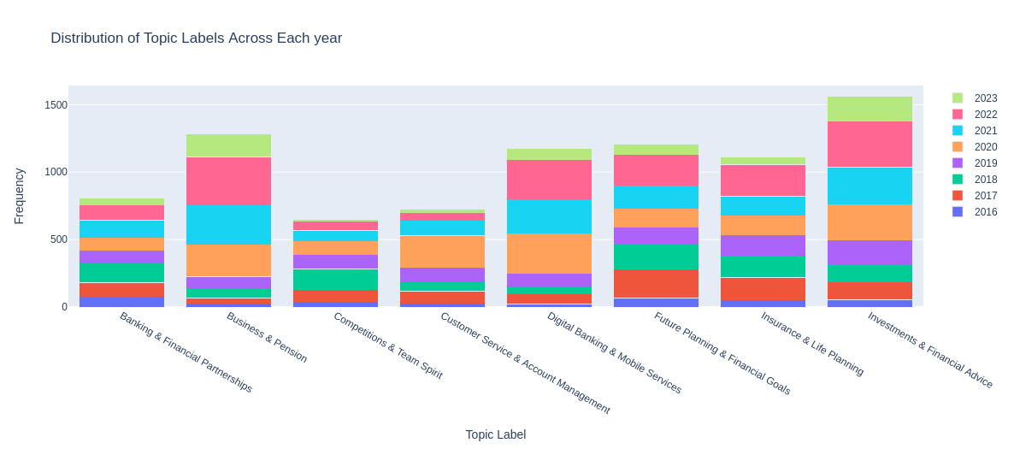

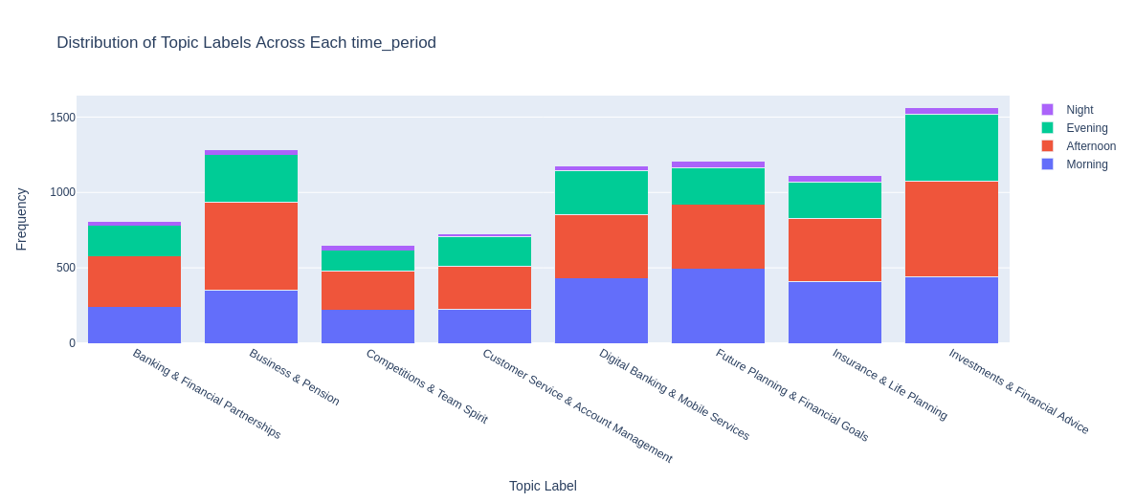

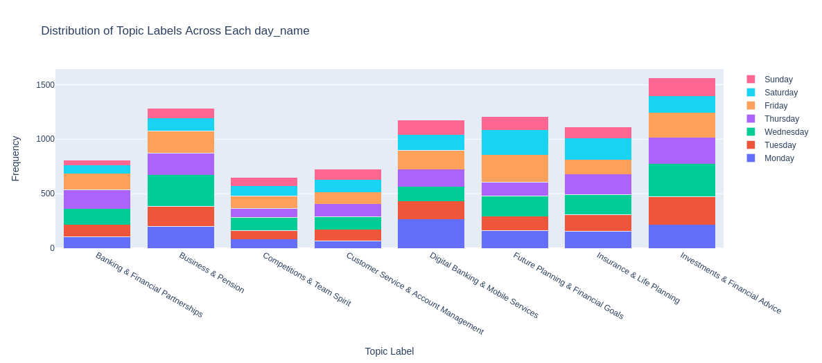

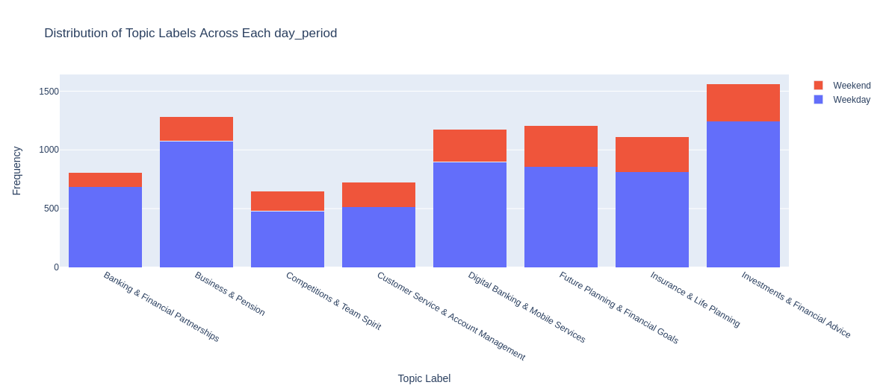

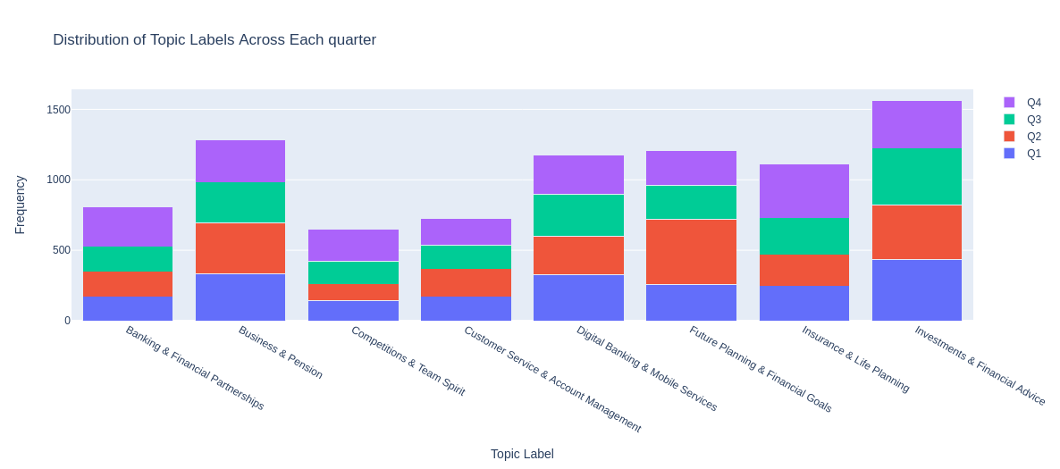

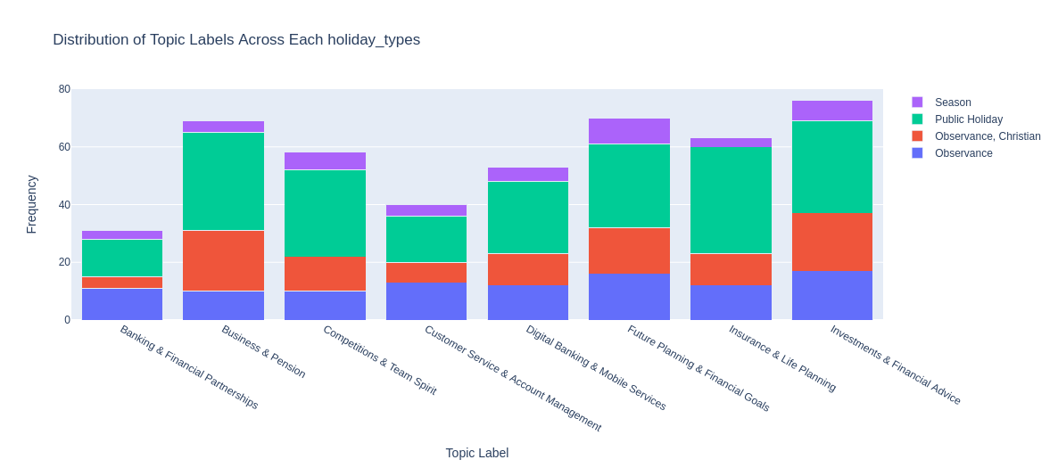

Based on the data shared, here are some insights that can be derived:

1. **Yearly Frequency**: The topic “Business Growth & Banking Services” has seen a consistent increase in frequency over the years, indicating growing interest in this area. On the other hand, “Digital Banking & Account Management” saw a significant jump in frequency in 2020, suggesting a possible shift in focus or interest that year.
2. **Time of Day**: Most topics see the highest frequency during the afternoon, with “Digital Banking & Account Management” and “Investment & Future Planning” leading in terms of absolute numbers. This could suggest that these topics are most relevant or engaging during work hours.
3. **Day of the Week**: All topics see the highest frequency on weekdays compared to weekends, indicating that these discussions are likely driven by professional or business contexts.
4. **Quarterly Frequency**: Most topics see a fairly even distribution across quarters, with some exceptions like “Savings & Promotions” which sees a significant increase in Q4. This could be related to end-of-year sales or promotional activities.
5. **Holiday Types**: Most topics see the highest frequency on regular days compared to holidays, suggesting that these discussions are more common in routine business contexts. However, “Investment & Future Planning” sees a relatively higher frequency during holidays, which could be due to people planning their finances around holiday spending or bonuses.

# Actionable recommendations

Based on the insights derived from the data, here are some actionable recommendations that could benefit the company:

1. **Optimize Posting Time**: Since posts made in the afternoon, particularly on Thursdays, tend to generate the most impressions and engagements, consider scheduling more posts during these times to maximize reach and engagement.
2. **Focus on High-Performing Topics**: The topics “Business Growth & Banking Services” and “Savings & Promotions” consistently generate high impressions and engagements. Consider creating more content around these topics to engage your audience effectively.
3. **Leverage Organic Reach**: Since the majority of impressions are organic, continue focusing on creating high-quality content that resonates with your audience rather than relying heavily on paid promotions.
4. **Monitor Engagement Metrics**: Keep a close eye on reactions, likes, comments, and shares as these metrics have a strong positive correlation with impressions and post clicks. This can help you understand what type of content resonates most with your audience.
5. **Consider Seasonality**: There are noticeable spikes in impressions and engagements at certain times of the year (e.g., Q1 for impressions and Q4 for engagements). Plan your content calendar accordingly to take advantage of these seasonal trends.
6. **Regular Posting**: Maintain a regular posting schedule to keep engagement levels high. Posts made on regular days tend to have significantly higher engagements than posts made on holidays.
7. **Focus on High-Performing Topics**: The topics “Business Growth & Banking Services” and “Savings & Promotions” consistently generate high impressions and engagements. Consider creating more content around these topics to engage your audience effectively.
8. **Optimize Content for Engagement**: While “Community Engagement & Events” reaches a wide audience, it has lower engagements. Consider optimizing the content for this topic to make it more engaging. This could involve incorporating more interactive elements or addressing trending topics within the community.
9. **Improve Content for Underperforming Topics**: The topics “Digital Banking & Account Management” and “Insurance & Pension Services” have lower engagement rates and post clicks. Consider improving the content for these topics, perhaps by making it more relevant, interesting, or actionable.
10. **Leverage High Engagement Rates**: The topics “Health & Sustainable Development” and “Investment & Future Planning” have high engagement rates but lower impressions and post clicks. Consider promoting these topics more to increase their reach, as they seem to resonate well with those who do see them.
11. **Maintain Regular Posting Schedule**: Regular posting appears to be key to maintaining high engagement levels. Consider maintaining a regular posting schedule, even during holidays.
12. **Analyze Content Complexity**: The complexity of a topic, as indicated by POS and NER counts, could influence its popularity and engagement. Consider analyzing your content’s complexity and adjusting it as necessary to ensure it’s accessible and engaging to your audience.
13. **Focus on High-Performing Topics**: The topic “Business Growth & Banking Services” has seen a consistent increase in frequency over the years, indicating growing interest in this area. Consider creating more content around this topic to engage your audience effectively.
14. **Leverage Popular Times**: Most topics see the highest frequency during the afternoon and on weekdays. Consider scheduling more posts during these times to maximize reach and engagement.
15. **Seasonal Planning**: Some topics like “Savings & Promotions” see a significant increase in Q4. Plan your content calendar accordingly to take advantage of these seasonal trends.
16. **Holiday Posting Strategy**: While most topics see the highest frequency on regular days, “Investment & Future Planning” sees a relatively higher frequency during holidays. Consider tailoring your posting strategy for holidays based on the topic.
17. **Monitor Emerging Trends**: “Digital Banking & Account Management” saw a significant jump in frequency in 2020, suggesting a possible shift in focus or interest that year. Keep an eye on emerging trends and adjust your content strategy accordingly.

# Conclusion

On LinkedIn we have an average Impression of 1083, having our max Impressions at 37980.0. Our mean engagements value is 50, having our max engagements value at 6235.0.